**Faculty of Science and Technology 420-436-VA | System Development**

# DELIVERABLE #1

**Due Date:**

Monday February 3rd, 2025

**Orange Team**

Nicholas Roy

Phoeuk Thao

Parth Patel

**Client:** Depanneur du Souvenir

**Contact Name:** Lay Patel

# SIGNATURES

We certify that this assignment is our own work.

I, **Nicholas Roy, student ID# 6247371**, certify that I have contributed to this deliverable, N-R

I, **Phoeuk Thao, student ID# 2256614**, certify that I have contributed to this deliverable, P-T

I, **Parth Patel, student ID# 6228271**, certify that I have contributed to this deliverable, P-P

# STATEMENT

**(Code from our E-Commerce class will be used for certain features of this project)**

# TABLE OF CONTENTS

DELIVERABLE #1 1

SIGNATURES 2

STATEMENT 2

TABLE OF CONTENTS 3

1.1 EXECUTIVE OVERVIEW 5

1.2 CLIENT 6

1.2.1 DESCRIPTION 6

1.2.3 COMPUTER SKILLS AND LITERACY 6

1.2.4 DESCRIPTION OF THE BUSINESS PROBLEM 6

1.3 TEAM ORGANIZATION 7

1.3.1 TEAM MEETINGS 7

1.3.2 REPOSITORIES 7

1.3.4 COMMUNICATION STRATEGY 8

1.3.5 AREAS OF RESPONSIBILITY 9

1.3.6 CLIENT CONTACT 9

1.3.7 REPORTS 10

1.3.8 TEAM CONTACT INFORMATION 11

1.4 PROJECT PLAN 12

DELIVERABLE #2 15

2.1 EXECUTIVE OVERVIEW 16

2.2 Description of the Business 17

2.3 Open Questions 17

2.4 The Questionnaire 18

2.5 User Stories 19

Table Views 19

Administrator 21

Employee 23

2.6 User Map 23

DELIVERABLE #3 25

3.1 EXECUTIVE OVERVIEW 26

3.2 Summary description of the client 26

3.3 Description of the business problem 26

3.4 Narrative Description 27

3.5 Flowchart 28

3.6 User Case Diagram 34

3.7 Sequence Diagram 36

3.8 Class Diagram 38

3.9 Appendix 5 38

# 1.1 EXECUTIVE OVERVIEW

Our project is to create a **Store Management System** for a client. Our client, **Lay Patel**, is the owner of a convenient storelocated in Laval. To complete this project, we will meet every Monday during our System Development class from 10:00 AM to 12:00 PM and Friday 8:30 AM to 11:30 AM. To keep track of our progress, we will have an online meeting every Wednesday after 6:00 PM. We will be using Discord to keep in touch and to call since it allows us to share our screen. If any of the members are not active on discord, we also made a group chat so we Text Message each other if needed.

Parth Patel will be responsible for relaying information from the client to the rest of the team.

Our team will use GitHub as our repository throughout the project to minimize the risk of data loss from a USB key. We will also use Jira to sort out tasks in order of priority and Microsoft Project to create our project plan. A new team project leader will be assigned every deliverable. Tasks will be divided according to members’ preferences and strengths, whether it be backend, frontend, or database work.

# 1.2 CLIENT

## 1.2.1 DESCRIPTION

Our client’s name is Lay Patel. He is the owner of a convenient store (or depanneur) called **Dépanneur Du Souvenir**. The store is like any other convenient store, selling multiple types of products such as candies, sodas, chips, drinks, even groceries and more. To manage the complication of creating multiple categories, our program will allow the user to insert their own categories based on their needs.

## 1.2.3 COMPUTER SKILLS AND LITERACY

The client has some computer knowledge. The owner’s skills are like any other average user. Thus, it is important for the program to have a simple and easy to use design. For now, the owner of the store will be the primary user even if he has few employees. The owner usually works more, which is why he wants to be the only user for now, but in the future, he will have his employees be the user.

## 1.2.4 DESCRIPTION OF THE BUSINESS PROBLEM

Our client’s main issue is keeping track of his inventory. He makes a list on paper to track what products he needs to buy or order. The issue with this is that he can sometimes forget what he needs to buy if the list is not well done. Therefore, he needs a program that tracks his inventory, a program that keeps track of the amount of the product. He also wants a program that keeps track of the prices of the product. The database and program will mainly be in English since he only knows English but will also support French for his employees.

# 1.3 TEAM ORGANIZATION

## 1.3.1 TEAM MEETINGS

Our weekly meetings will be every Monday from noon to 14:00 PM and Friday from 8:30 AM to 11:30 AM at Vanier College during our System Development classes. We will have also virtual meetings which will be held on Wednesdays from 19:00 PM to 20:00 PM via Discord.

Discord Link: <https://discord.gg/FchMEFny>

## 1.3.2 REPOSITORIES

Below is a link to our GitHub repository in which we will store everything related to our project, namely our code. In addition, we will also be storing the ﬁnalized versions of our deliverables, reports, and project plan in this repository.

### GitHub repository link:

<https://github.com/Yeeteronii/InventoryManagement.git>

Here is each team member’s GitHub username:

|  |  |
| --- | --- |
| USERNAME | NAME |
| Yeeteronii | Phoeuk Thao |
| MicrowaveBallin | Nicholas Roy |
| ParthPatelA | Parth Patel |

Microsoft Word will be used for our reports. We chose Microsoft Word instead of Google Docs because we find Word to be more friendly to use and simpler for our team.

For task organization, Jira will be used. Jira will as well document the progress and owner of each task. Below you ﬁnd a link to our Jira project:

### Jira link:

<https://yeeteronii.atlassian.net/jira/software/projects/IN/boards/1>

Lastly, we will use Microsoft Project for our project plan.

## 1.3.4 COMMUNICATION STRATEGY

We will be communicating through Instagram and Discord. Instagram will be used for more casual communication, such as asking questions about our deliverable reports or informing the team of any new information that has come to light. Discord will be primarily used for meetings as its voice call and screen-sharing features make it ideal for this type of communication. For these purposes, we have created group chats on both Instagram and Discord.

We will meet synchronously during System Development class on Monday from noon to 14:00 PM and Friday from 8:30 AM to 11:30 AM whenever we are given the time to work on the project in class.

For our meetings on Wednesdays, we will use Discord to communicate via call from 19:00 PM to 20:00 PM from our homes.

The **policies** we have established are as follows:

|  |  |
| --- | --- |
| **POLICY** | **DESCRIPTION** |
| Respect each team member. | Allow each member’s opinions and ideas to be heard. |
| Team decisions must be made through votes, such as through polls via Instagram. | All team members are required to vote unless they explicitly state that they don’t have a preference for personal reasons. This includes reviewing each other's GitHub branches before committing to main. |
| Prioritize teamwork. | Team members should ask for help if they are struggling, and other members must step in to assist. |
| Team members must follow the project plan. | Team members are expected to complete their assigned tasks on time, as per the project plan. If they are unable to do so, they must inform the other members or seek help if needed. |
| All team members are required to show up for scheduled meetings. | All team members are expected to be present at all scheduled meetings. In the event of an absence, a reason must be provided, and the other members must be informed. |

## 1.3.5 AREAS OF RESPONSIBILITY

The minute-takers for each meeting will Phoeuk Thao and Nicholas Roy.

The main point of contact with our client will Parth Patel, as he is the most familiar with the client.

Most tasks and responsibilities will rotate among team members. The SCRUM master for each deliverable will be the team leader for that same deliverable. For the task of team leader, the instructor will select the leader for the ﬁrst deliverable, while the members will choose the leader for subsequent deliverables. However, the roles of minute-taker and point of contact will remain unchanged and will not rotate among members. This consistency for the minute-taker role is crucial for maintaining cohesive and reliable meeting notes.

For the implementation of the ﬁnal product, we have already chosen which member will work on each task. Below you will ﬁnd the members assigned to each implementation task.

|  |  |
| --- | --- |
| **IMPLEMENTATION TASK** | **NAME** |
| Back-end Development | Nicholas Roy |
| Front-end Development | Phoeuk Thao |
| Database | Parth Patel |

## 1.3.6 CLIENT CONTACT

The point of contact with the client for the duration of the project will be

Parth Patel. We have decided not to change the point of contact during each delivery. This is because Parth Patel will know the client and is more suited to ask our client since our client is his co-worker.

## 1.3.7 REPORTS

The team leader will be responsible for ensuring that the necessary reports are prepared properly, and on time for each deliverable.

Below you will ﬁnd the team leaders for each deliverable.

|  |  |
| --- | --- |
| **DELIVERABLE #** | **TEAM LEADER** |
| **1 |** Project plan | Nicholas Roy |
| **2 |** Client and business domain summaries, questionnaire | Parth Patel |
| **3 |** User stories | Phoeuk Thao |
| **4 |** Use cases and UML Diagrams | Phoeuk Thao |
| **5 |** Database design | Parth Patel |
| **6 |** Prototype UI and client comments | Nicholas Roy |
| **7 |** Implementation and client comments | Nicholas Roy |

## 1.3.8 TEAM CONTACT INFORMATION

Below you will ﬁnd each team member’s name, email address, and phone number.

|  |  |  |
| --- | --- | --- |
| **NAME** | **EMAIL** | **PHONE NUMBER** |
| Parth Patel | parth2023patel@gmail.com | 514-677-6245 |
| Nicholas Roy | [nicholas@patroy.ca](mailto:nicholas@patroy.ca) | 438-521-2234 |
| Phoeuk Thao | [thaotfay@gmail.com](mailto:thaotfay@gmail.com) | 438-725-8966 |

# 1.4 PROJECT PLAN

Our inventory management system project will be based heavily on the format given in class so as to not to overcomplicate things. So far, no difficulties have arisen regarding the organization of tasks, as all members are passionate about their individual roles to play in the project. Due to past experiences with unorganized Git repositories in the past, we’ve agreed to use a more secure, and organized arrangement. By each using our individual branches, we can review each other's work before pushing to the main branch. This should save time, reducing mishaps in future development.

Our initial vision for the program is to facilitate a display of product data in tables sorted by category, and to allow the user to insert their own categories. This allows for easier management and is intended to be used by store or inventory managers. This modular approach allows us to use our product for other purposes again in the future, with minimal adjustments.

We took careful consideration when dividing tasks among group members, ensuring they were not assigned arbitrarily. To maximize efficiency, we assigned tasks based on each member's strengths. Parth handled the majority of client-related and database tasks, Nicholas was responsible for back-end development and UML design, and Phoeuk took charge of front-end development, UI, and documentation.

For the common tasks that are repeated for each deliverable, such as deliverable document design, we decided it was fitting to assign it to Parth for the first few deliverables since they aren’t heavy in database design. For the later submissions we decided to evenly space these common tasks, so Parth can stay motivated with greater endeavors.

Note that although we do have strict assignments for each team member, we will allow ourselves to trade tasks with one another if our motives change in development. However, we will each try our best to stick to our main section of expertise for the project. Additionally, it is important that we work closely with one another to help with unresolved issues and to ensure that our final product is cohesive, rather than 3 separate functions hastily glued together.

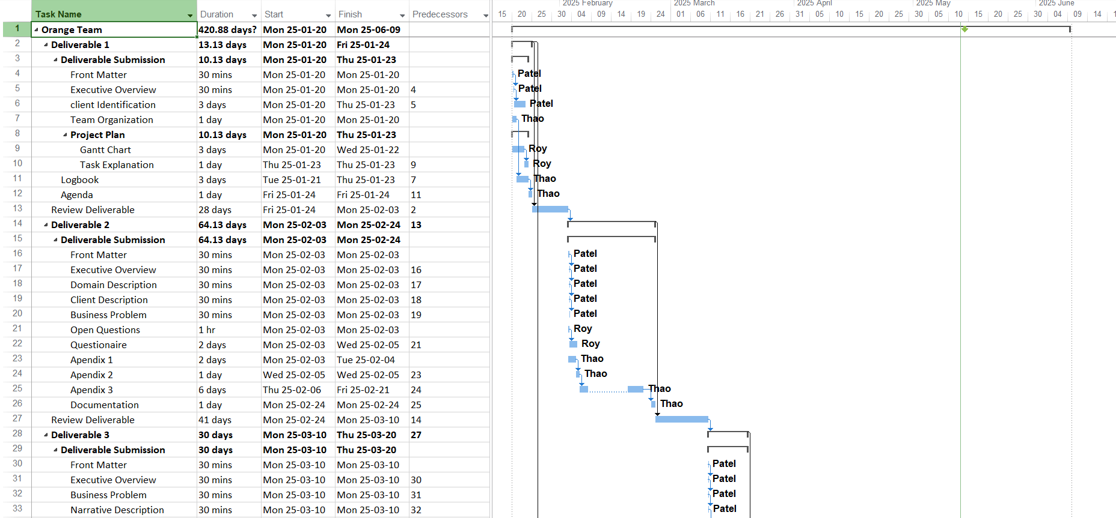

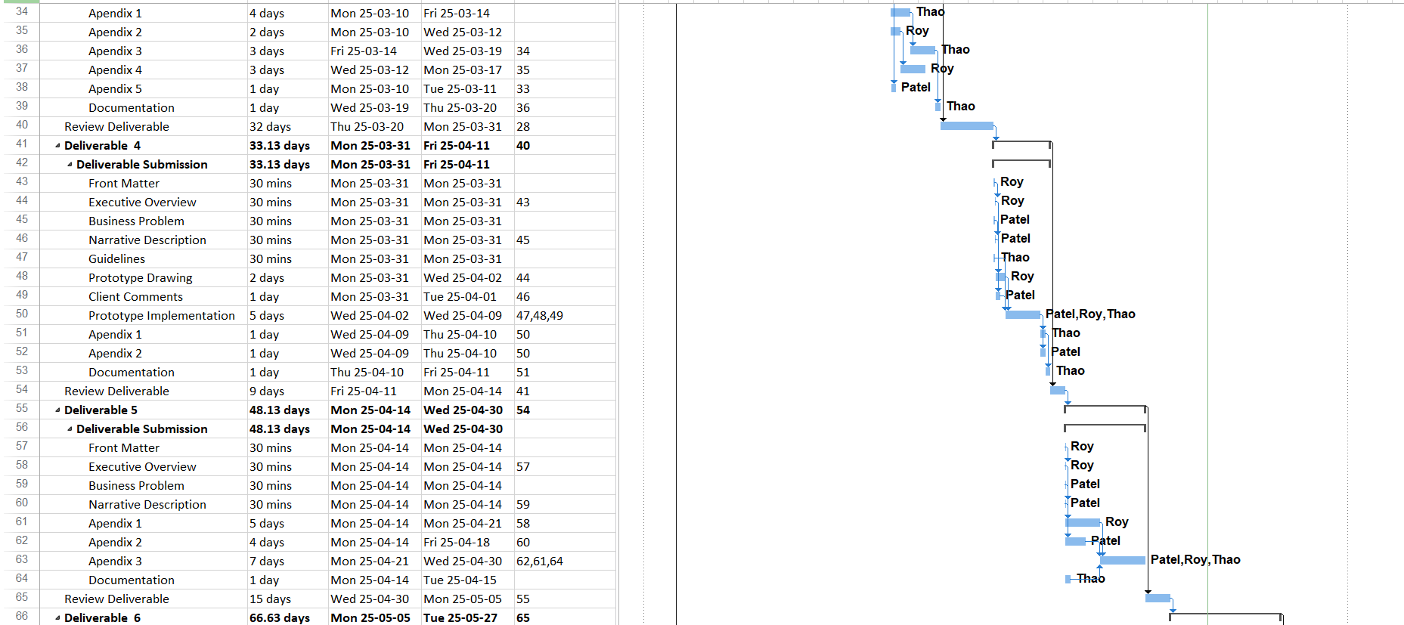

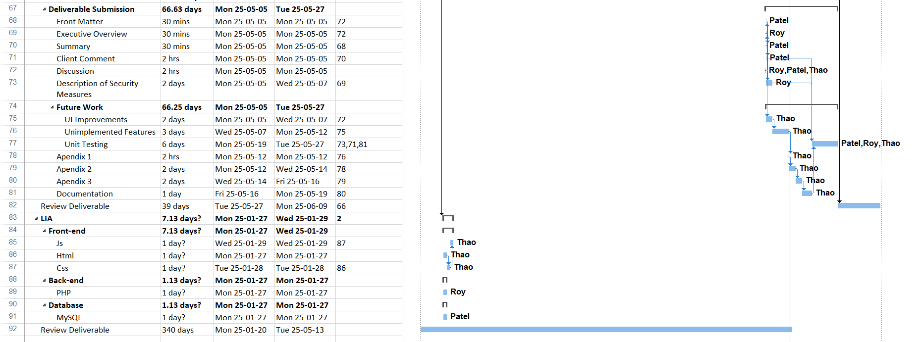

**Faculty of Science and Technology 420-436-VA | System Development**

# DELIVERABLE #2

**Due Date:**

Monday February 21st, 2025

**Orange Team**

Nicholas Roy

Phoeuk Thao

Parth Patel

**Client:** Depanneur du Souvenir

**Contact Name:** Lay Patel

# 2.1 EXECUTIVE OVERVIEW

This project is about making a Store Management System for the Depanneur du Souvenir that will help the business be more organized when working.

In this Deliverable, we find out about what the client, Lay Patel, wants in the program as well as how he works and runs the business. We dive into the business problem and then we ask the clients our questions to get a better idea on how the Store Management System should be. Based on the client’s answers and information, the delivery focuses on the creation of the user stories which will give us an idea on how each user will be able to do in the system.

# 2.2 Description of the Business

The business is a convenience store which is a retail business. The business environment of Depanneur du Souvenir is selling multiple types of products to the consumer. The customers go to the store to purchase consumable products. Our client has owned this convenient store for almost 5 years now and he manages to run the store without having any specific technological system. The retail business of convenience stores is like any other retail store. Our client buys and orders products and sells them to all customers. The products sold in the store are drinks, food, cigarettes, frozen food, and more. For a depanneur, other convenient stores are the competition. For our client, this competition doesn’t affect him a lot, since there isn’t any other convenient store in the neighborhood.

Our client’s name is Lay Patel, who is the owner of Depanneur du Souvenir. He bought the business in 2020-21 and has been running it ever since. He has 3 employees that work at the store. The client has basic computers skills just like any other average user. His daily computer task would be emailing, ordering products, browsing the web just like any other average user. He does have the ability to learn how an application works quickly. So, once we show him how our web-application works, he won’t have a lot of trouble using it.

The business problem is of our client is keeping track of his inventory. He also needs a store management system where he can keep track of his orders, his suppliers, his employees and reports. The client uses pen and paper to keep track of his inventory and wants to have a more efficient way to know his inventory. At the same time, he needs to keep track of his orders and deliveries. Therefore, our Store Management System will help the client be more efficient and organized to run and manage the store.

# 2.3 Open Questions

For the Store management system, we know that we want an inventory system, but does he want to keep track his orders and suppliers. He has multiple employees; does he want to manage who works when? Does he maybe want a feature to keep track of which employee is working, so a clock in clock out feature (shift management). How does our client order a product for the store, by phone, online or maybe another way. On the web-application, we assume he wants to order the products that are in low stock, does he want an order button to let him put the products he needs to buy in like a shopping list. We are also assuming that he will do a report about his earnings. How do we do it? Does he manually calculate the earnings he’s made in a month.

# 2.4 The Questionnaire

1. What type of data would you like to have on the product table? Do you want a price column with and without tax for each column?

**In the Product Table I would like to have the name of the product, the product type(category), the price of the product without and with tax, as well as the price that I paid for the product.**

1. How do you order supplies/ products for the store. Do you want to keep track of the suppliers on the website?

**The orders depend on the product, so products like alcoholic beverages are ordered from a supplier, as well as milk, and certain snacks. There are other products that I go buy physically from stores like Club Entrepot, Costco, or more. Having a page with all the suppliers is useful to keep all the supplier information in one place.**

1. How do you manage the price for a product, like what price do you order from the suppliers, is it with or without taxes?

**From the suppliers, I buy it at their prices which gets tax, then I decide the price to sell however I want.**

1. How do you handle low stock.

**So, most of the time, at the end of the week, I check the stock, to see what is low and what is not. I consider low stock less than 5 quantity wise. At the same time, It depends on the product, certain products take more time to sell than other, so low stock is different.**

1. Would you like an option to create a “shopping list” for low-stock products? (A button that allows him to put the product in a list.

**Yes, that is useful, so I can see a list of what to order and from that list, I can make the purchases.**

1. Do you want to have a feature to manage employees, to manage their schedule and possibly have a clock-in/clock-out feature to track his employees’ shifts.

**I would like to have a feature where I can put the schedule of the employee. Employees can also see that schedule. The clock-in/clock-out feature is not necessary to do since the schedule is a fixed weekly schedule. The schedule does not change every month or week unless there is a major change.**

1. How do you track your earnings?

**There is a report made by the cash register and I just calculate manually how much I made each month.**

1. Do you want a feature to keep track of his reports, like a logbook. Or do you want the system to make the report?

**I would prefer to put in earnings, profits and loss by myself, in case there are items that are not in the system, and I would prefer just to keep it as a log book so I can quickly view it when I need to.**

1. Do you want to keep track of the deliveries coming in?

**Yes, I have no problem, it would be more like me entering the data of a delivery so I know when what is coming?**

1. How does he want the delivery/orders page to look like if he wants to implement it?

**To be answered in the future.**

1. What other features would you like to have?

**That’s mostly it, I can’t think of more things, since the main program I wanted was only an Inventory System, but your recommendations could help me be more organized.**

# 2.5 User Stories

## Table Views

### Stock Management

(See 2.4 Questionnaire – 1)

**User Story:**

As a General User,

I want to view inventory items in a clear and concise manner,

So, I can easily track and manage stock.

**Gerkin Syntax:**

Given I am logged into the system

When I navigate to the inventory page

Then I see a table displaying all inventory items with relevant details such as name, quantity, and category

### Table Layouts

**User Story:**

As a General User,

I want all tables available to me (Product Inventory and Employee Calendar for all users, Orders, Reports for Admin users) easily accessible through a sidebar widget,

So, I can easily navigate the program and use it efficiently.

**Gerkin Syntax:**

Given I am on the main dashboard

When I click on the sidebar menu

Then I see a list of available tables and can select and navigate to any table from the sidebar

### Item Categorization

**User Story:**

As a General User,

I want to list items by type category, as well as create, edit, update, and delete my own categories,

So, they can be easily visualized.

**Gerkin Syntax:**

Given I am on the inventory page

When I select a category filter

Then I see only the items belonging to that category

### Stock Threshold Indication

(See 2.4 Questionnaire – 4)

**User Story:**

As a General User,

I want an indicator on each item that compares current stock quantity to expected stock quantity,

So, I can easily track my current stock, and what products I need to resupply.

**Gerkin Syntax:**

Given I am on the inventory page

When I view the stock quantity of an item

Then I see an indicator comparing the current stock to the expected stock level, highlighting low stock items in red

### Inventory Record Creation

**User Story:**

As an Admin User,

I want to enter items into the inventory database using only the necessary fields,

So, record insertion can be quick and easy.

**Gerkin Syntax:**

Given I am on the inventory entry form

When I fill out the required fields and submit the form

Then the new item is added to the inventory database and visible in the inventory list

### Searching Records

**User Story:**

As a General User,

I want to search for specific strings within each table,

So, I can easily remove, update, delete, and track items.

**Gerkin Syntax:**

Given I am on the inventory page

When I enter an item name in the search bar

Then I see matching records displayed in the table

### Creating Records

**User Story:**

As an Admin,

I want to add records to my inventory,

So, I can better track said items.

**Gerkin Syntax:**

Given I am on the record creation page

When I enter the necessary information and submit the form

Then a new record is created in the inventory

### Adding to Cart

**User Story:**

As a General User,

I want to add product records to a cart,

So, the admin can know what items to order.

**Gerkin Syntax:**

Given I am on the product page

When I add an item to the cart

Then a new record is created in the Order Table.

## Administrator

### Admin Access

**User Story:**

As an Admin,

I want a separate administrator login,

So, only I can have access to certain important features like orders and reports for better store security.

**Gerkin Syntax:**

Given I am on the login page

When I enter my admin credentials

Then I gain administrative access

### Two-Factor Authentication

**User Story:**

As an Admin User,

I want all user to authenticate their identity via email,

So, I can ensure business information security.

**Gerkin Syntax:**

Given I have the right username and password

When I click on the log in button

Then I will receive a notification to verify my credibility using an authenticator.

### Creating Users

**User Story:**

As an Admin User,

I want to create user accounts for my employees,

So, my employee accounts can remain secure.

**Gerkin Syntax:**

Given I am on the create user page

When I input a new employee information

Then I create a new employee

### Orders View

**User Story:**

As an admin,

I want to view my product orders,

So, I can easily track deliveries.

**Gerkin Syntax:**

Given I am on the admin dashboard

When I navigate to the orders page

Then I see all product orders with relevant details

### Report View

(See 2.4 Questionnaire – 7)

**User Story:**

As an Admin,

I want to record earnings,

So, I can track my analytics and optimize my store accordingly.

**Gerkin Syntax:**

Given I am on the reports page

When I enter an earning

Then I can view the earnings data

### Employee Scheduling

(See 2.4 Questionnaire – 6)

**User Story:**

As an Admin,

I want to schedule my employees’ working hours for a grid,

So, we may both easily track hours, and thus function more efficiently.

**Gerkin Syntax:**

Given I am on the employee scheduling page

When I assign shifts to employees on a weekly grid

Then the shifts are saved, and employees can view them

## Employee

### Employee Login

**User Story:**

As an Employee,

I want my own login details,

So, I can easily track my own working hours, stock items info.

**Gerkin Syntax:**

Given I am on the login page,

When I enter my employee credentials

Then I am logged in and can view my personal dashboard

# 2.6 User Map

`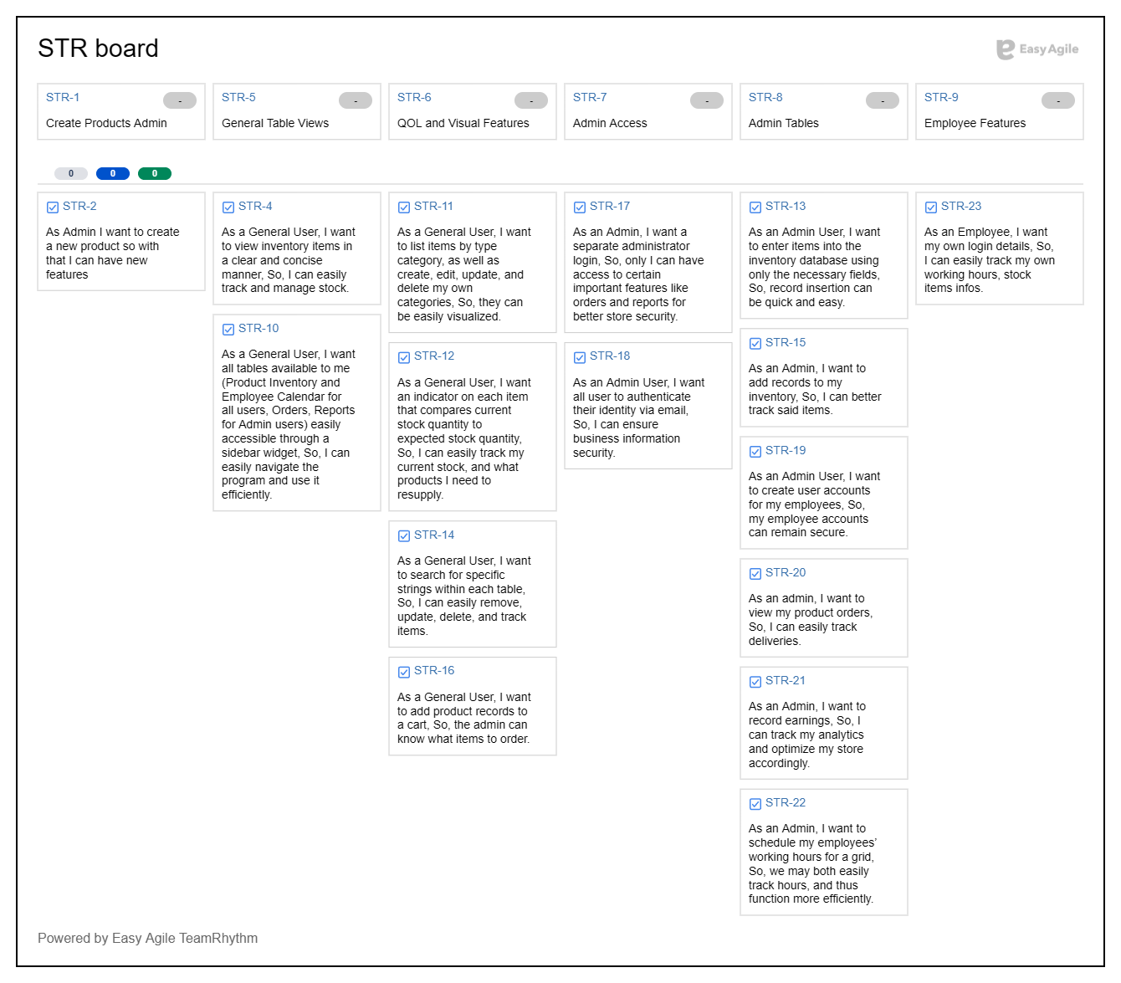

**Faculty of Science and Technology 420-436-VA | System Development**

# DELIVERABLE #3

**Due Date:**

Monday March 16th, 2025

**Orange Team**

Nicholas Roy

Phoeuk Thao

Parth Patel

**Client:** Dépanneur du Souvenir

# 3.1 EXECUTIVE OVERVIEW

This project is about making a Store Management System for the Depanneur du Souvenir that will help the business be more organized when working.

In this Deliverable, we find out about what the client, Lay Patel, wants in the program as well as how he works and runs the business. We dive into the business problem and then we ask the clients our questions to get a better idea on how the Store Management System should be. Based on the client’s answers and information, the delivery focuses on the creation of the user stories which will give us an idea on how each user will be able to do in the system.

# 3.2 Summary description of the client

Lay Patel, the business owner of Depanneur du Souvenir, is our client. He has been managing the business since he purchased it in 2020–21. At the store, he employs three people. Like any other typical user, the client is proficient in the basics of computers. Like any other typical user, he would use his computer every day to email, order things, and browse the internet. He is capable of picking up on an application's functionality fast. He won't have much issue using our web application once we demonstrate how it operates.

# 3.3 Description of the business problem

The business problem is of our client is keeping track of his inventory. He also needs a store management system where he can keep track of his orders, his suppliers, his employees and reports. The client uses pen and paper to keep track of his inventory and wants to have a more efficient way to know his inventory. At the same time, he needs to keep track of his orders and what he needs to buy for the store. Therefore, our Store Management System will help the client be more efficient and organized to run and manage the store.

# 3.4 Narrative Description

Both admin and employee can login in the program, using their username and password. Both users are redirected to the main page where they have all the pages linked in the side bar.

As an employee, I have access to the shift/schedule page, products page, as well as the settings of the program. The employee can go to the product table/page, and update the quantity of the product, the employee can also put a product in the order list.

The employee can also check their shifts/ schedule in the shift page.

In the settings the employee can change the language English to French for the employee’s preference.

As the admin of the system, I can access all pages, which are, shift/schedule page, products page, settings page, orders list page, supplier page, employee page, and report page.

As the admin, in the product page, I can create, update and delete a product. The admin can also put a specific product on the order list page.

The admin can then access the order list page, where he sees all the products that need to be purchased for the store. He can also check the list of all the suppliers where he can add and remove suppliers.

The admin can go in the shift table to make the schedule or change anything in the schedule for the employee. The employee can be created by the admin from the employee page.

The admin has accessed the reports page, where he can enter his report and log, to keep track of what he has made. It is almost like a personal logbook.

The admin can go in the settings, where he can change the language preferences and can update his personal/account credentials.

# 3.5 Flowchart

# 3.6 User Case Diagram

# 3.7 Sequence Diagram

# 3.8 Class Diagram

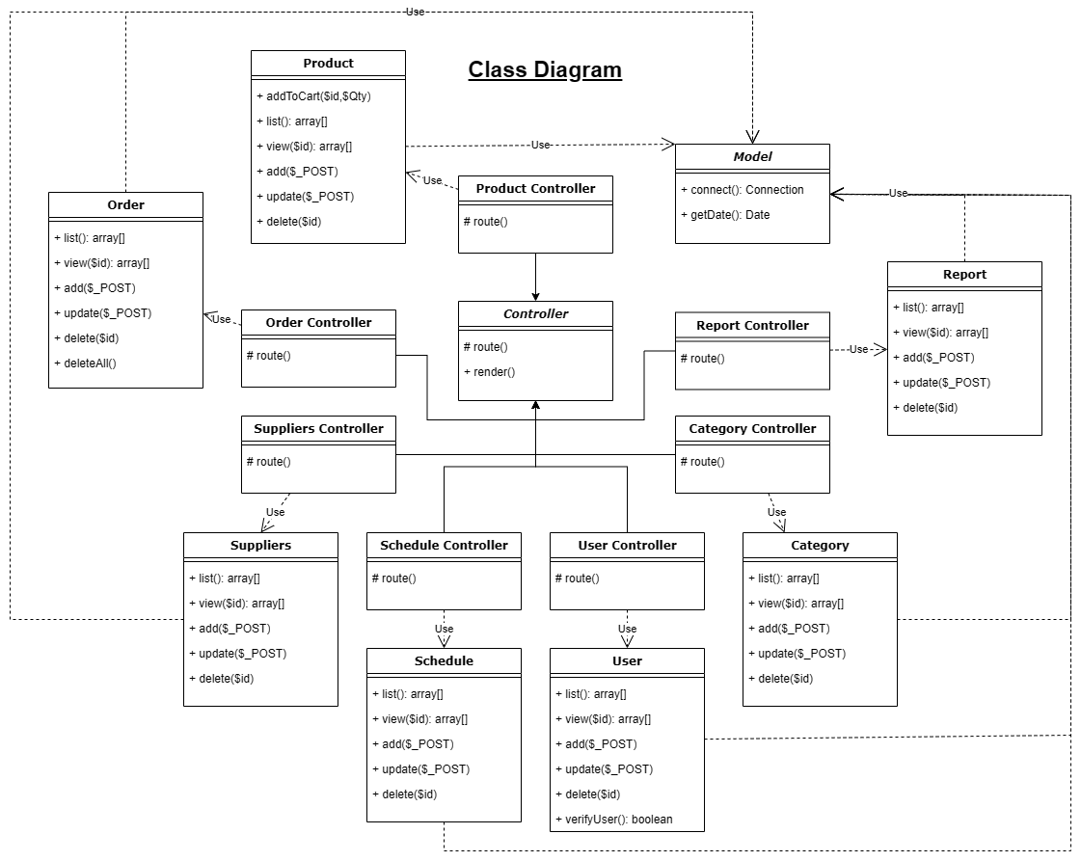

# 3.9 Appendix 5

The client was not willing to share any documents to present for this project.